|  |
| --- |
| Date/Location |
| 03/11/2022 @Zoom, 2:00 – 3:00 PM |

|  |  |
| --- | --- |
| Attendees | |
| Client | MAVDEV |
| Joe Saceric | Ammar Lokhandwala |
| Umera Khan | Maria Frausto |
|  | Michael Gurch |
|  | Victoria Sheraden |
|  | Vivian Bui |

|  |
| --- |
| Meeting Agenda |

1. **Current Trello Board**

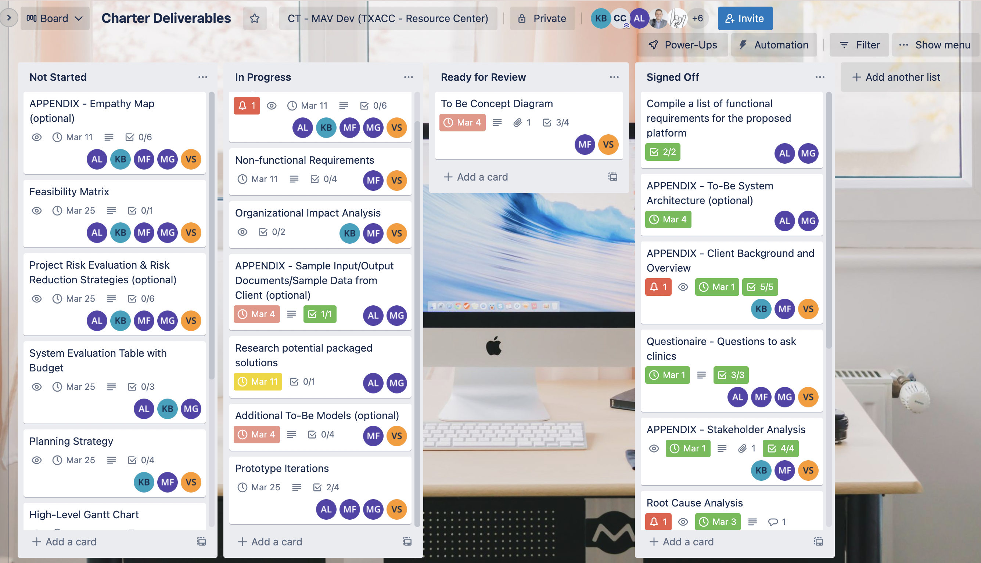

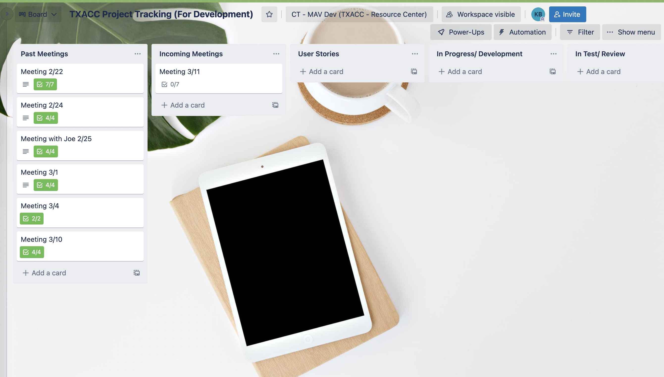

1. **Discussion Agenda**
2. Review potential solutions
3. Review User Stories
4. Review Non-functional Requirements
5. Review Organizational Impact Analysis
6. Sign-off Trello
7. About Sprint Kick-off
8. Schedule Sprint Kick-off